My DataraFlow Cohort 2 Journey: Mastering Advanced Python (Week 2 Take-Home Exercises)
Raji Faruq Ishola
2026-09-15
Hello, my wonderful network and fellow tech explorers! 🤗
As part of my incredible learning adventure in the DataraFlow Cohort 2 program, I am thrilled to share my complete walkthrough, practical code solutions, and deep insights from our Week 2 Take-Home assignments. This journey has not only sharpened my engineering skills but has also taught me how to write cleaner, more reusable, and production-ready code. My goal in sharing this comprehensive breakdown is to help anyone navigating object-oriented programming, iterators, polymorphism, and scope to gain valuable clarity and hands-on guidance! 🗺️✨

Course 1: Object-Oriented Programming (OOP) 🍪
Object-Oriented Programming is like designing blueprints for a manufacturing factory. A Class serves as our master template or cookie cutter, while an Object represents the individual products we bake and customize from that blueprint.

Task 1: Constructor and String Formatting
Task: Insert the missing parts to make the code return John (36) using a constructor and string formatting.
class Person:
# This initializes our object with unique attributes when instantiated
def __init__(self, name, age):
self.name = name
self.age = age
# This defines how our object is represented as a text string
def __str__(self):
return f"{self.name} ({self.age})"
# Instantiate our object with custom data
p1 = Person("John", 36)
# Print the object instance, triggering our __str__ method automatically
print(p1)

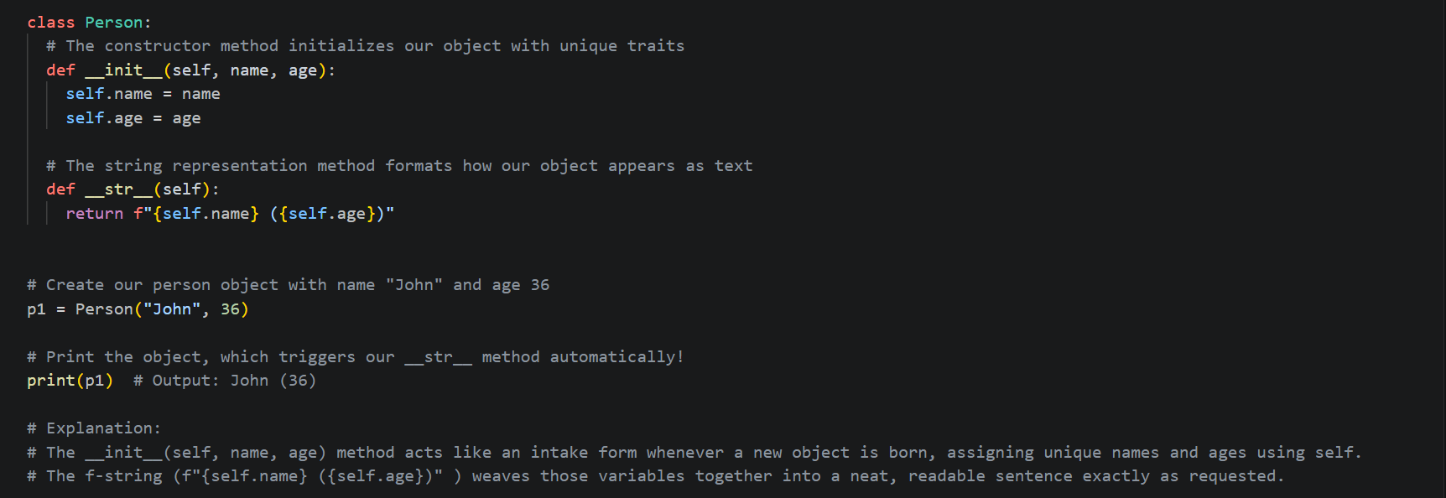

Detailed Explanation and Commentary: This demonstrates how we define initialization logic using the __init__ constructor and format object outputs using the special __str__ method. When we pass "John" and 36 into Person("John", 36), Python binds those values to our object instance via self, allowing our f-string to return John (36) cleanly when printed.

Task 2: Classes, Objects, and Properties
Task: Create a class named MyClass, instantiate an object called p1, and use it to print the value of x.
class MyClass:
# Define a class property
x = 5
# Instantiate our object
p1 = MyClass()
# Access and print the property using our object instance
print(p1.x)

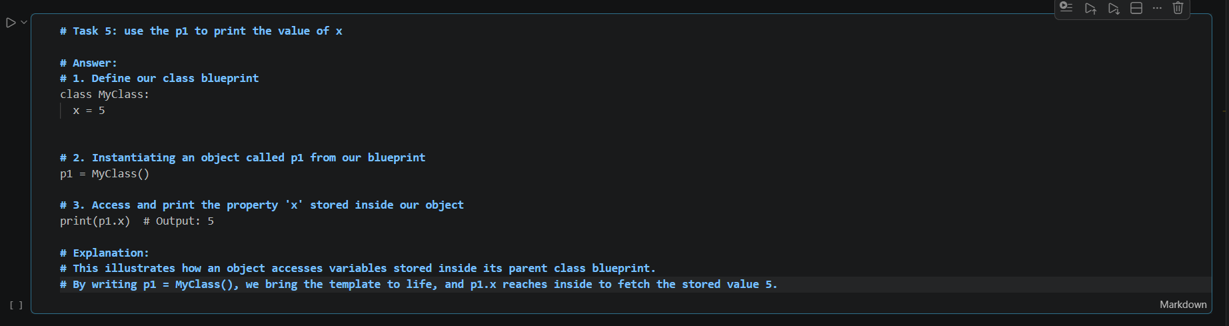

Detailed Explanation and Commentary: This illustrates how an object accesses variables stored inside its parent class blueprint. By writing p1 = MyClass(), we bring the template to life, and p1.x reaches inside to fetch the stored value 5.

Course 2: Inheritance 🧬✨
Inheritance allows us to pass down traits from a parent class to a child class, keeping our codebase DRY (Don’t Repeat Yourself). Think of it like a family recipe book where children inherit master recipes and add their own signature twists.

Task 1: Animal Subclass Sound Overriding
Task: Create a base class Animal with attributes name and sound, and a method make_sound(). Create subclasses Dog and Cat that override make_sound() to print "Woof!" and "Meow!".
class Animal:
# This sets up our base animal attributes
def __init__(self, name, sound):
self.name = name
self.sound = sound
def make_sound(self):
print(self.sound)
class Dog(Animal):
def __init__(self, name):
# This uses super() to inherit initialization from the parent Animal class
super().__init__(name, "Woof!")
# Instantiate and test our subclass
dog = Dog("Bingo")
dog.make_sound() # Output: Woof!

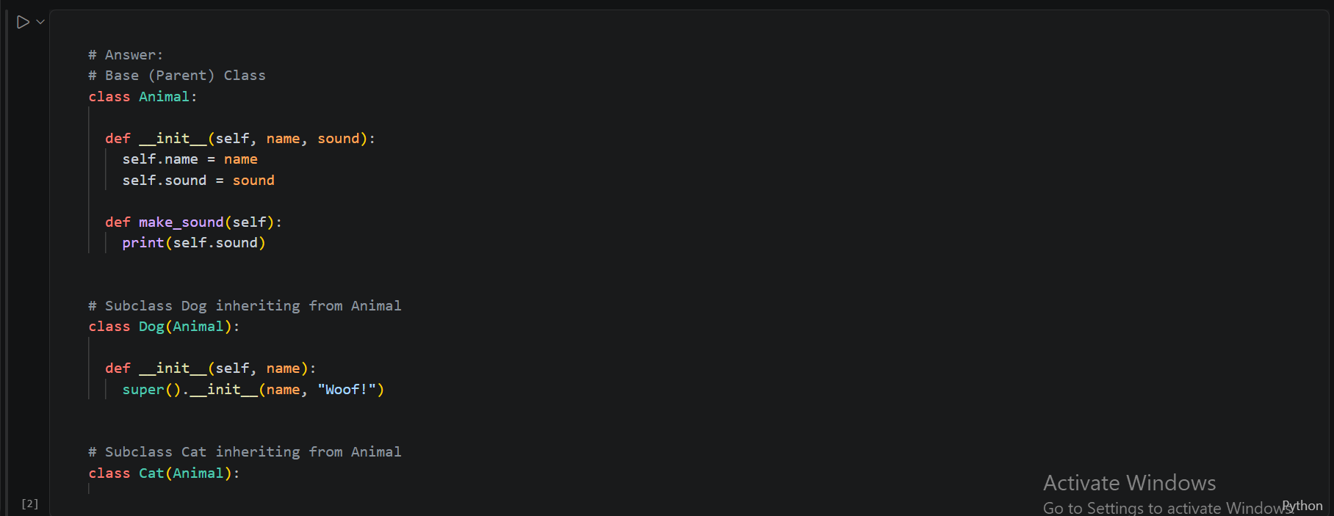

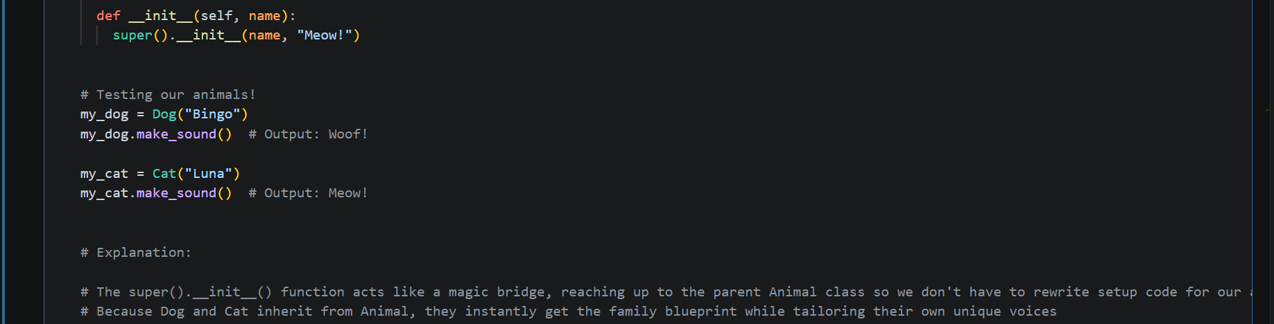
Detailed Explanation and Commentary: This illustrates how super().__init__() bridges our child class to the parent class, letting us inherit base setup logic without rewriting code. By extending Animal, our Dog class gains all parent capabilities while tailoring its own unique sound behavior.

Task 2: Vehicle Hierarchy and Method Overriding
Task: Create a base class Vehicle with attributes brand and model, and a method display_info(). Create a subclass Car that adds doors and overrides display_info().
class Vehicle:
def __init__(self, brand, model):
self.brand = brand
self.model = model
def display_info(self):
print(f"Vehicle: {self.brand} {self.model}")
class Car(Vehicle):
def __init__(self, brand, model, doors):
super().__init__(brand, model)
self.doors = doors
def display_info(self):
print(f"Car: {self.brand} {self.model}, Doors: {self.doors}")
# --- Execution ---
my_car = Car("Toyota", "Camry", 4)
my_car.display_info()

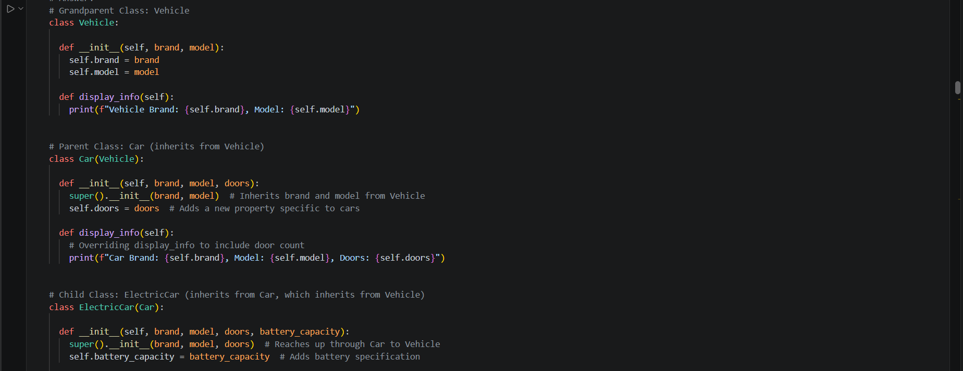

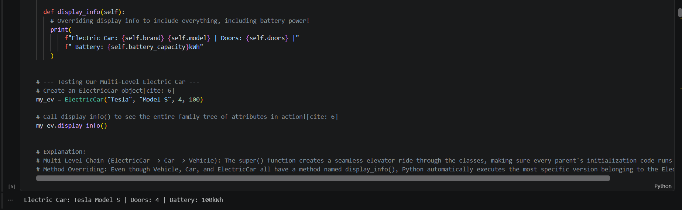
Detailed Explanation and Commentary: This demonstrates method overriding in inheritance, where a child class modifies an inherited method to present specialized information unique to its type.

Course 3: Iterators 🌀✨
An iterator acts like a bookmark in a massive book, allowing us to traverse through elements sequentially one item at a time without loading an entire collection into computer memory all at once.

Task 1: Custom CountDown Iterator
Task: Create a custom iterator class CountDown that takes a number n and counts down to 1 using __iter__() and __next__().
class CountDown:
def __init__(self, n):
self.n = n
def __iter__(self):
# This returns the iterator object itself to initiate the protocol
return self
def __next__(self):
# This yields the next sequential value or stops the iteration
if self.n > 0:
val = self.n
self.n -= 1
return val
else:
raise StopIteration
# --- Execution ---
for num in CountDown(3):
print(num)

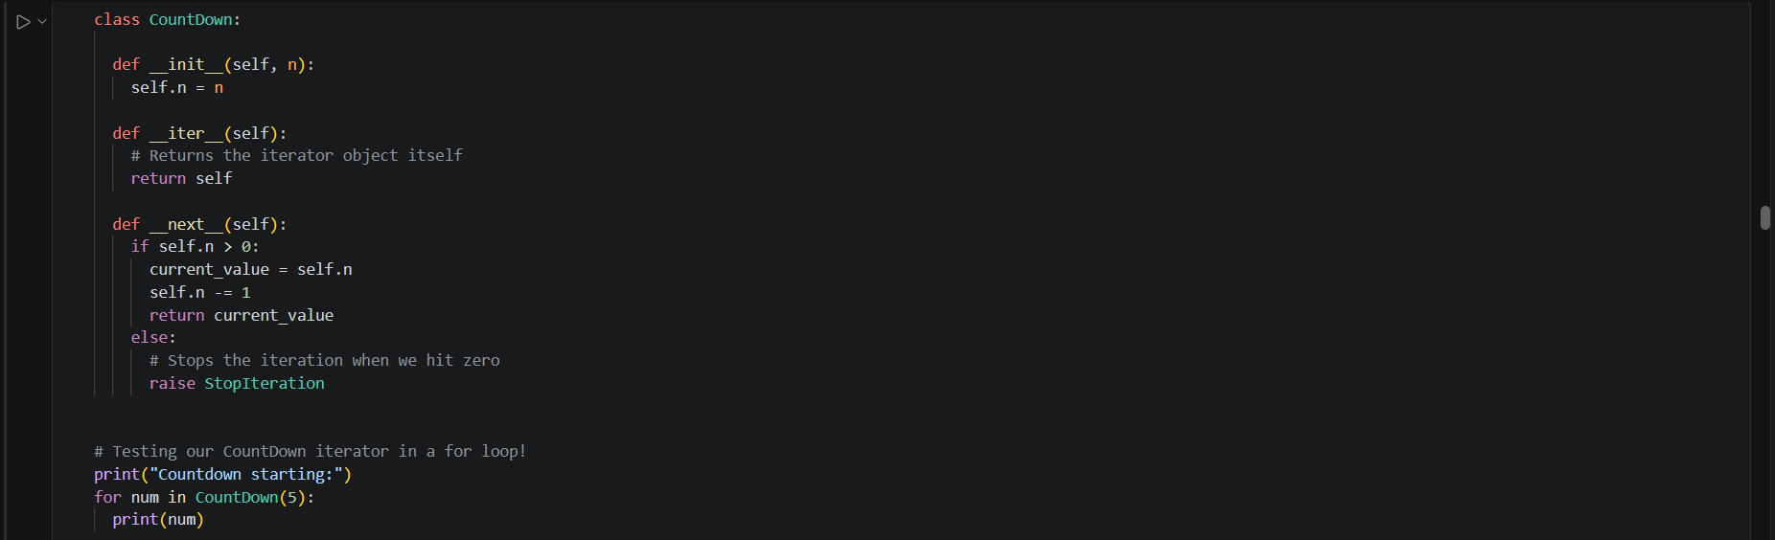

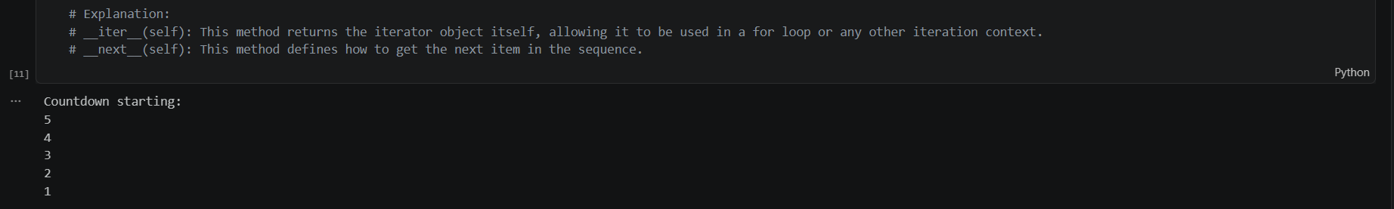
Detailed Explanation and Commentary: This demonstrates how custom iterators maintain internal state across loop cycles. Every time the for loop requests an item, __next__() executes, decrementing our counter until it hits zero and raises StopIteration to exit cleanly.

Task 2: List Iterator with Exception Handling
Task: Take a list of numbers [10, 20, 30, 40, 50], convert it into an iterator using iter(), and retrieve each element using next() while handling StopIteration gracefully.
numbers = [10, 20, 30, 40, 50]
my_iter = iter(numbers)
while True:
try:
# Retrieve items sequentially one by one
print(next(my_iter))
except StopIteration:
print("Reached the end of the iterator safely!")
break

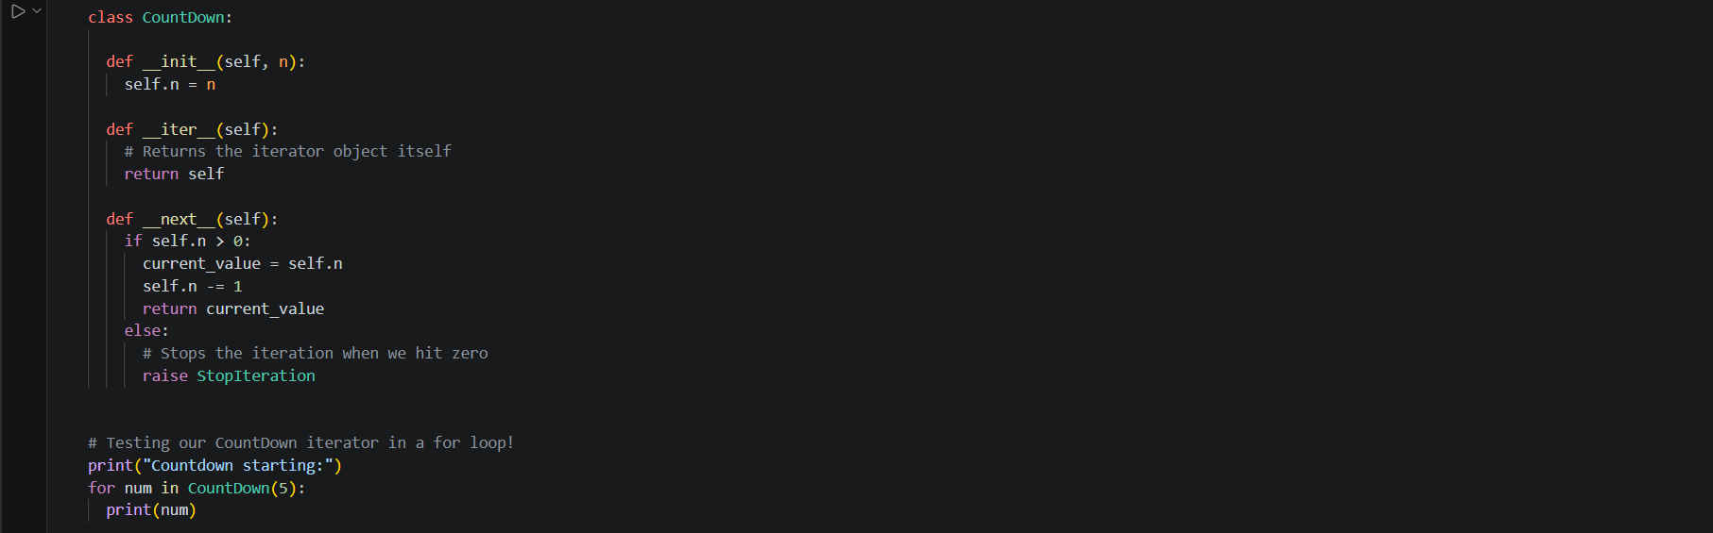

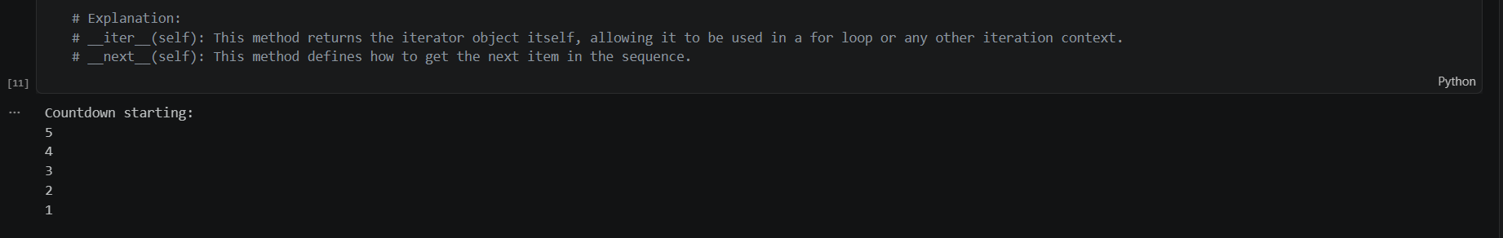
Detailed Explanation and Commentary: This illustrates how we process sequences element-by-element using explicit next() calls and catch the StopIteration exception to terminate our loop without crashing.

Course 4: Polymorphism 🎭✨
Polymorphism means "many forms". It allows different classes to share identical method names while executing completely customized behaviors behind the scenes.

Task 1: Bird Language and Consumer Function
Task: Create a base class Bird with speak(), subclasses Parrot and Crow that override it, and a function make_bird_speak() that accepts any bird object.
class Bird:
def speak(self):
return "Chirp"
class Parrot(Bird):
def speak(self):
return "Squawk"
def make_bird_speak(bird_obj):
# This polymorphically invokes .speak() without checking the object's specific class type
print(bird_obj.speak())
# --- Execution ---
make_bird_speak(Parrot()) # Output: Squawk

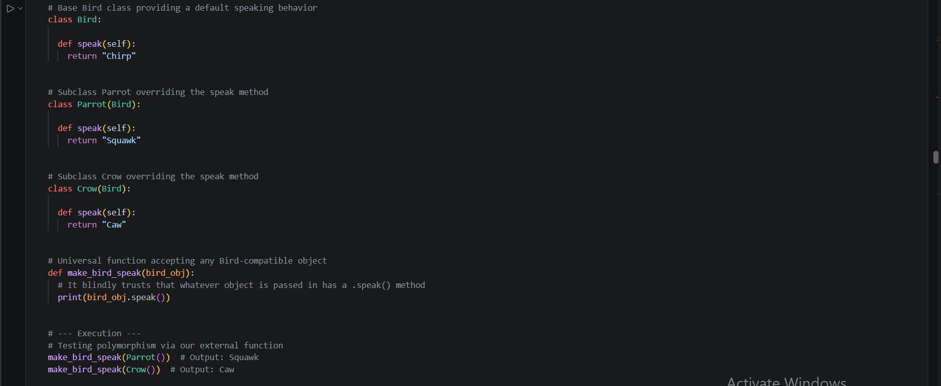

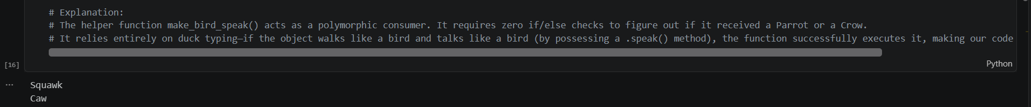
Detailed Explanation and Commentary: This highlights duck typing, where our consumer function relies entirely on the presence of the .speak() method rather than checking object classes explicitly. Polymorphism lets us write flexible, modular code that handles new subclasses effortlessly.

Task 2: Polymorphic Vehicle Movement
Task: Create two classes Car and Bicycle with a move() method, store them in a list, and loop through them calling move().
class Car:
def move(self):
return "Car drives"
class Bicycle:
def move(self):
return "Bicycle pedals"
# --- Execution ---
vehicles = [Car(), Bicycle()]
for v in vehicles:
print(v.move())

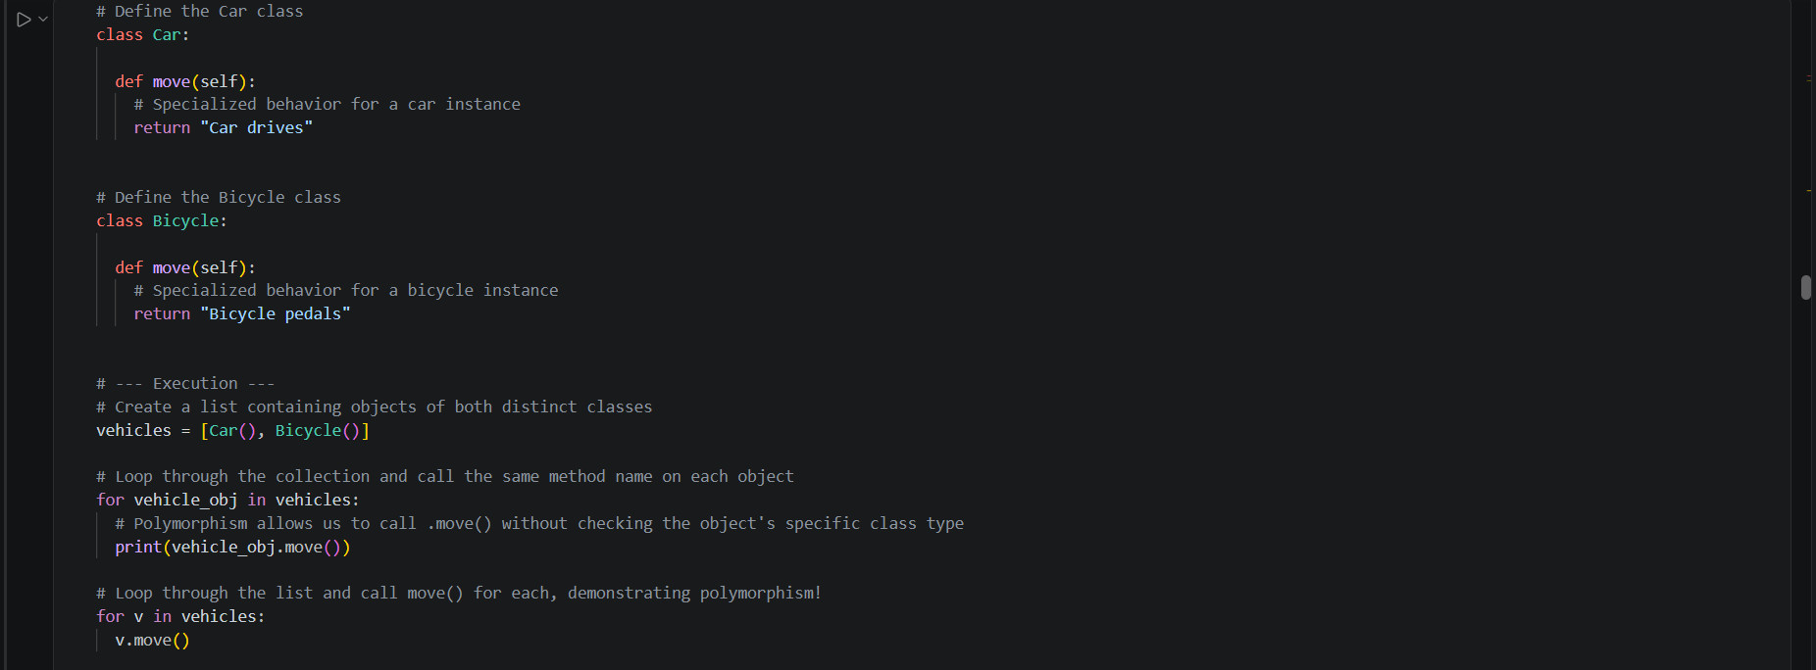

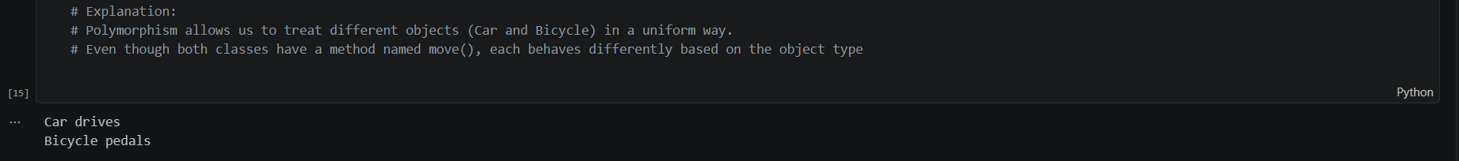
Detailed Explanation and Commentary: This demonstrates polymorphic iteration, allowing us to call identical method names across completely different classes without verifying their specific types beforehand.

Course 5: Variable Scope 🗺️✨
Scope dictates where variables live and can be accessed within our code, functioning much like personal drawers versus shared household tables.

Task 1: Modifying Global State
Task: Create a global variable total = 0, and inside a function add_to_total(n), use the global keyword to modify it across multiple calls.
# Initialize our global total tracker
total = 0
def add_to_total(n):
# This declares that we want to modify the global 'total' variable directly
global total
total += n
print("Updated global total:", total)
# --- Execution ---
add_to_total(5)
add_to_total(10)

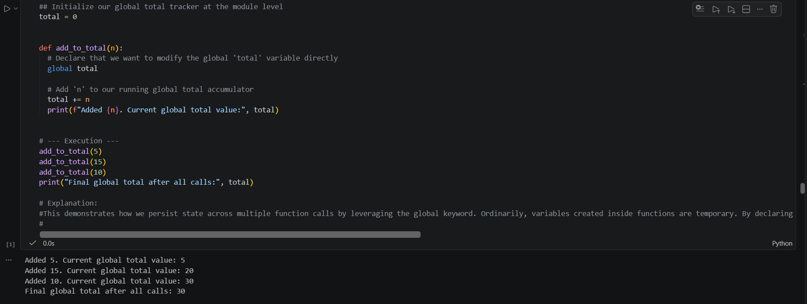

Detailed Explanation and Commentary: This demonstrates how state persistence is achieved using the global keyword. Ordinarily, variables created inside functions are temporary; adding global total instructs Python to link our function directly to the module-level variable to accumulate running sums.

Task 2: Nonlocal Keyword in Nested Functions
Task: Create a function outer() with a variable message = "Hi", and inside it, create a nested function inner() that modifies message using the nonlocal keyword.
def outer():
message = "Hi"
def inner():
# This modifies the enclosing variable from the parent scope
nonlocal message
message = "Hello from inner scope!"
inner()
print("Updated outer message:", message)
# --- Execution ---
outer()

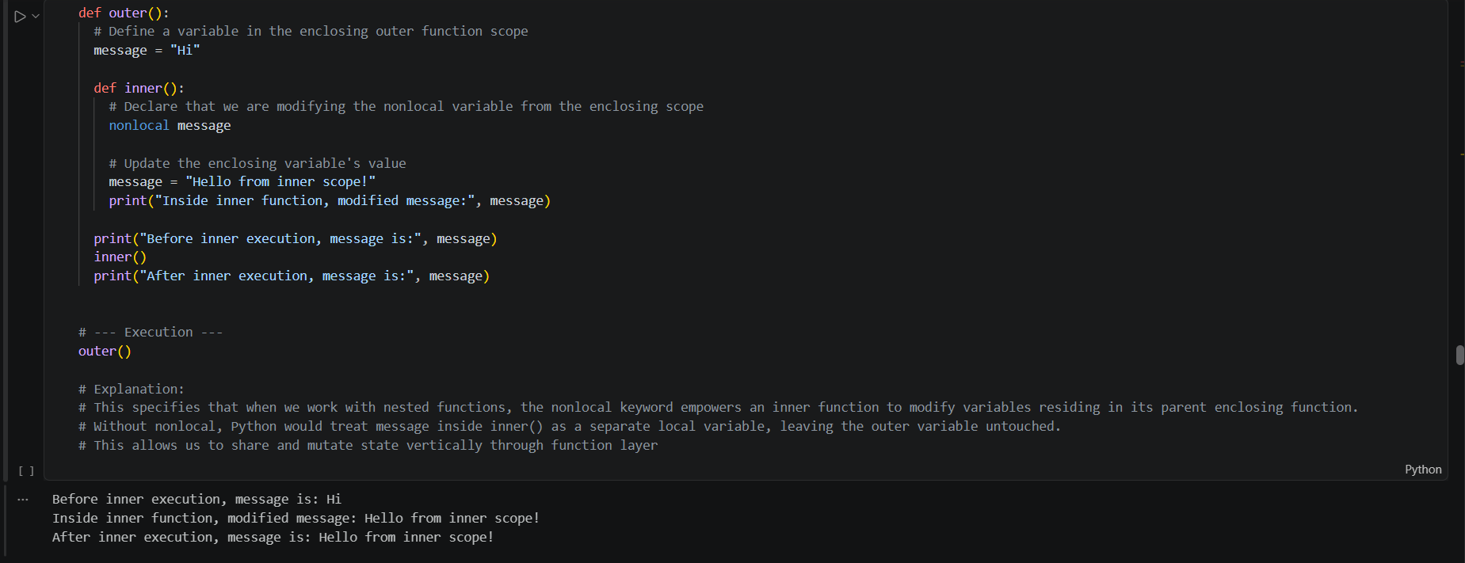

Detailed Explanation and Commentary: This illustrates how the nonlocal keyword enables nested inner functions to mutate variables residing in their parent enclosing function without elevating them to global status.

Assignment & Assessment Highlights 🚀📚

Task 1: Instance Tracking with Class Variables
Task: Create a Counter class with a class variable to track total instances created, and print the count after making several objects.
class Counter:
# Class-level variable shared across all instances
total_instances = 0
def __init__(self):
Counter.total_instances += 1
# --- Execution ---
obj1 = Counter()
obj2 = Counter()
obj3 = Counter()
print("Total instances created:", Counter.total_instances)

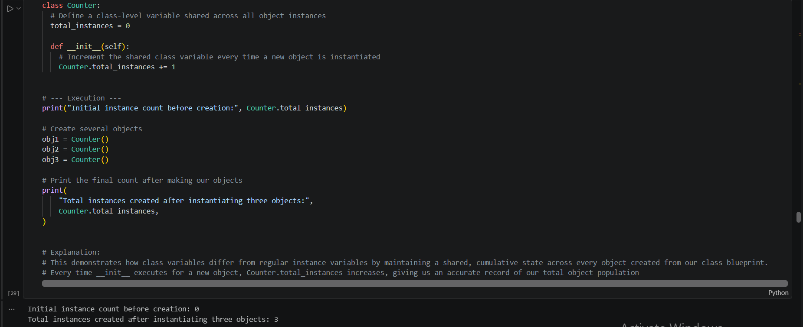

Detailed Explanation and Commentary: This highlights class-level variables, which maintain a shared state across all generated instances to track cumulative counts rather than resetting per object.

Task 2: Polymorphic Shape Area Aggregation
Task: Create classes Rectangle, Circle, and Triangle with an area() method, store instances in a list, and calculate total area without checking types.
import math
class Rectangle:
def __init__(self, w, h):
self.w, self.h = w, h
def area(self):
return self.w * self.h
class Circle:
def __init__(self, r):
self.r = r
def area(self):
return math.pi * (self.r ** 2)
# Store mixed shape instances in a single collection
shapes = [Rectangle(3, 4), Circle(2)]
# Polymorphically sum up areas without checking individual object types
total_area = sum(shape.area() for shape in shapes)
print(f"Calculated Total Area: {total_area:.2f}")

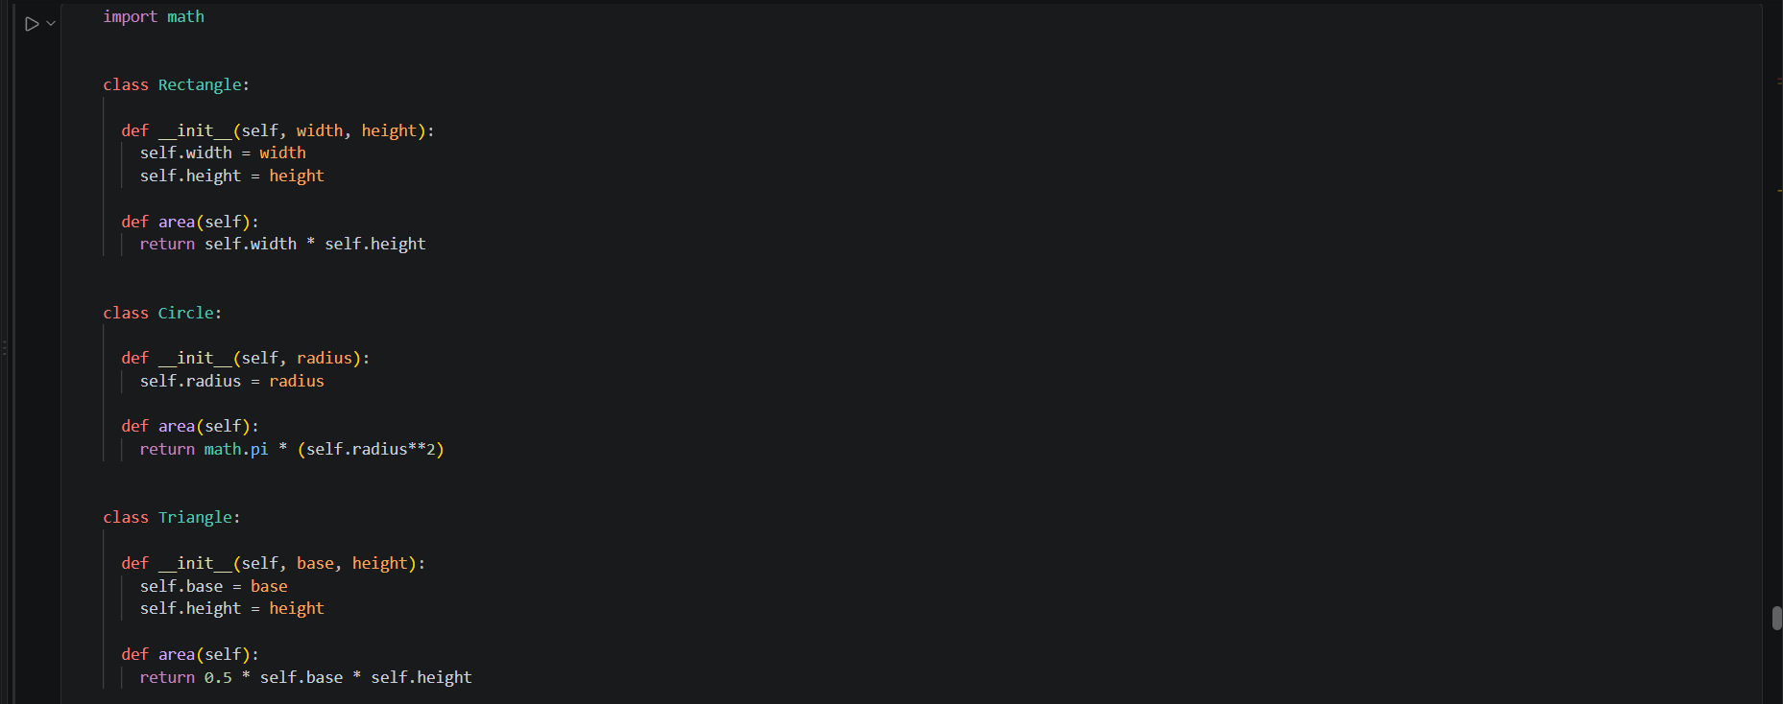

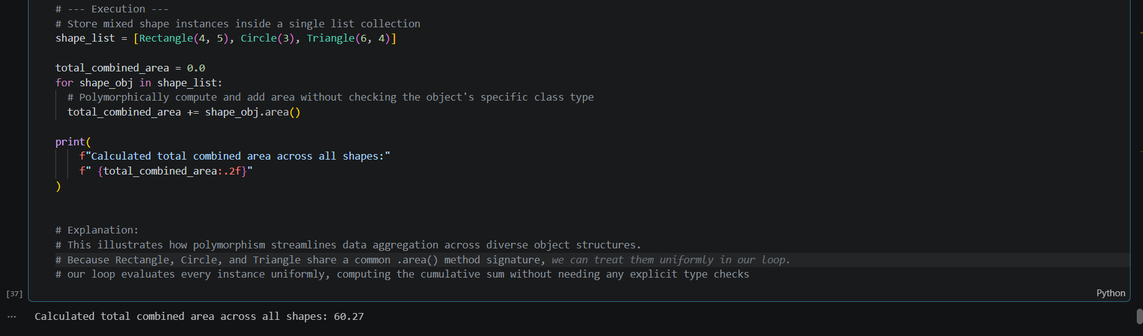
Detailed Explanation and Commentary: This illustrates polymorphic aggregation, enabling uniform processing of diverse object structures. Because every shape implements its own .area() method under a shared interface, our summation loop evaluates items seamlessly without conditional type checks.
What an incredible week of growth and discovery at DataraFlow! 🤗 I hope this deep dive into our exercises helps illuminate these core Python concepts for your own coding journey. Let me know which topic you would like us to explore next! ❤️✨

